**DESIGN DOCUMENTATION**

**SIMULATOR FOR AN APEX PIPELINE**

**Problem Statement:**

This project asked to design and code a Simulator for an APEX pipeline which is strictly in-order with two different function units.

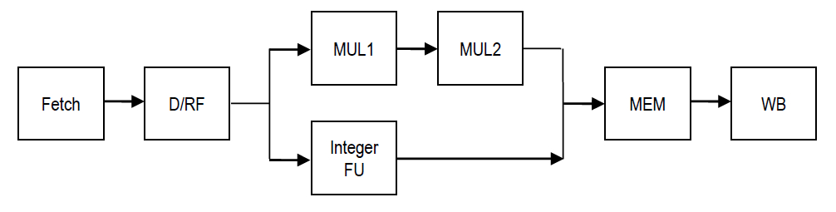Below is the graphical representation of the pipeline:

I have briefly described about the implementation of simulator in the below points:

**Java** is used for implementing the simulator for an in-order Apex pipeline. I have segregated all the stages and **each stage** is a **class**, which basically extends an Abstract class called as **Stage.**

there is a CPUContext Class which basically is the Brain of the code, where registers, memory array for load and store, instruction cache, program counter and instances of each stage is defined.

Our Main method is written in simulator class which basically ask User input from command prompt and act accordingly. On selecting initiate, it will set PC VALUE and reset all the registers, instruction cache, memory array to 0 and in simulation, Code will ask user to provide the number of clock cycle and according to that it will call that number of times to executeCycle method. Which is defined in CPU, this method executes all stages one by one, starting from WB till fetch (Bottom to up).

There is CPUUtils class, it basically has 3 methods, first one, it is used to calculate the registers index, secondly it tells whether the source is a literal or a register and last whether the register is locked or not.

**Algorithm/Flow:** Code have adopted the bottom up strategy, where WriteBack Stage is called first, followed by Memory and so on till it reaches **Fetch** stage. Main idea for starting from WriteBack is that, in this case we don’t need to concern about giving Instruction to next stage in next cycle and parallelly taking a new instruction in the same new cycle (which we need to do if we start executing fetch first).

Whereas, here in my algorithm, Program control starts from WriteBack (WB).

**Dependency:** Code handles true dependency, and for this isSourceLocked method is used which tells the dependency (this is present in CPUUtils) and it is called by D/RF everytime in isInstructionStalled method. Dependency is handled whenever there is a lock due to register.

We also handled the scenario when INT ALU and MUL ALU at same clock trying to move to MEM stage, in our problem MUL will always goes to MEM stage first.

Code makes BZ/BNZ to wait in D/RF stage whenever there is a Arithmetic instruction before it.

**Registers:** There is a register class with name, value and valid as data members, along with this it has 2 Boolean flags. Instance of this registers is created in CPUContext. All the registers are updated using its data member getter and setters. Total 16 registers are present which is defined in CPUContext.

**Memory Array:** A HashMap is created to simulate the RAM memory, here all STORE and LOAD instruction uses the memory location to store and load the data.

**Instructions:** A HashMap is created to store the list of Instruction coming from the input file. Load Instruction method in CPUContext puts the data into instruction map with Key as Program Counter and value as Instruction. Input file is read using scanner. (Each instruction is of 4 bit, thus PC value is incremented by 4). Data Members of Instruction are Instruction, Destination, Source1, Source2, Instruction string.

**ZeroFlag:** It is a Boolean flag used to control BNZ and BZ instruction, it sets whenever any arithmetic instructions give a zero result at WB.

**STAGES:**

**Write Back (WB):** Here Code will set the instruction by taking it from Memory (MEM) stage. If it is null then It will print nothing (which denotes NO-ops) and control will go to Memory stage (which will happen till no instruction reaches Memory instruction and in case of stalls) and but if MEM Stage has an instruction then WB will set that instruction and will write back to the Registers depending upon the instruction and sets the Zero Flag if arithmetic instruction produces a zero value on destination and it also release the locks at the end, After this program control will go to Memory Stage.

**Memory (MEM)**: Here Program’s control will set the instruction from its previous stage i.e. Execution or Multiplication ALU, depending upon the instruction type it will perform memory action. (LOAD and STORE instruction).

**Execution:** This stage will get its instruction from its previous stage i.e. D/RF and do the calculation depending upon the instruction type. There is a different ALU for Multiplication (2 ALU).

**Decode Register Files:** Flow will come to D/RF after Execution stage, here all the instruction will be stalled in case of TRUE dependency. Using **isInstructionStalled** and **isInstructionStalledAtNextStage,** using isSourceLocked method of CPUUtils. Also, here HALT will flush its following instruction once it is decoded. Here In this stage, Code splits Instruction string using regex pattern and stored the splited result as instruction’s member in instruction object.

**Fetch:** Program flow reaches here at the last, it will fetch instructions from instruction cache (Implemented in hashmap) depending upon the program counter value. Here we also check if fetch instruction is stalled due to Decode RF (which is also stalled due to bubble), This is achieved using **isFetchInstructionStalled** method which checks instruction present in fetch with instruction present in D /RF. Here 2 Boolean Flag are created isBranched and endOfProgram, this isBranched is used in case of Branch case, where we told not to end the program and instead run till the Branch condition is not satisfied, whereas endOfProgram is used to close the program. It will set to true whenever PC gets invalid value or null.